**EX.NO:1**

**DATE:**

**TOTAL ACHIEVED VALUE BASED ON THE SALESMAN AND PRODUCT**

Using the Array concepts in Excel find the Total Archived value based on the Salesman and Product for the below data.

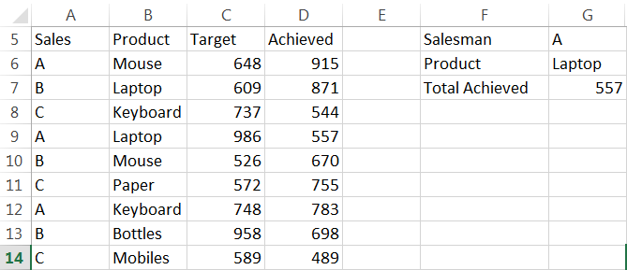

**Aim:**

To find the total archived value based on the Salesman and Product for the given data using the array concepts in excel.

**Algorithm:**

**Step 1:** Open MS-EXCEL using the below menu, we can open the MS Excel.

**Start -> All Programs -> Microsoft Office -> MS-Excel.**

**Step 2:** Enter the given Salesman Name in Column A, Product in column B, Target Sales in Column C and Sales Achieved detail in Column D in the excel sheet.

**Step 3:** As an Input Parameter, enter the Salesman Name “A” in Cell G5

**Step 4:** Enter the Product details cell G3, for an example enter as “laptop”.

**Step 5:** To find the value achieved by salesman “A” for the Product “laptop”, Enter the below formula in cell B4 as below

**=SUM (IF ((A3:A11=G2)*(B3:B11=G3), D3:D11))**

**Step 6:** Alter entering the above formula in cell B4 and Click “**Ctrl + Shift + Enter**” we will get the expected output.

**Step 7:** We will get the expected output **557** in the cell B4.

**Step 8:** With the help of this formula, we can find the total value achieved by different salesman for different products. Save and Close the File.

**Output:**

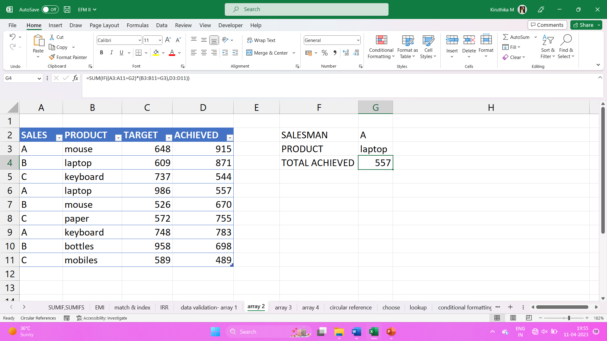

**EX: NO: 2**

**DATE:**

**SUM OF OUTPUT OF A PERSON A**

**Calculate the Sum of Output of a person A, for the month of Jan, Feb and Mar using the below data dynamically.**

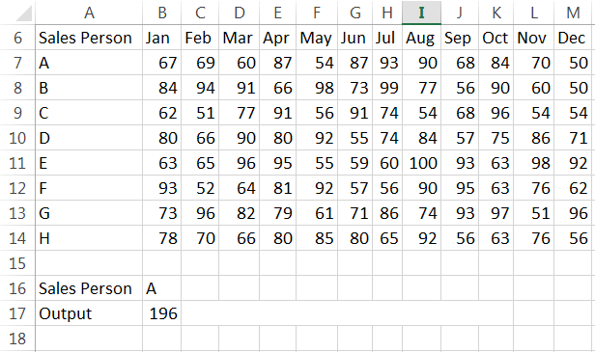

**Aim:** To calculate the sum of output of a person A, for the month Jan, Feb and Mar using the given data, with the help of MS- EXCEL.

**Algorithm:**

**Step 1:** Open MS-EXCEL by using the command start- all programs- Microsoft office- MS-Excel

**Start -> All Programs -> Microsoft Office -> MS-Excel.**

**Step 2:** Type the given salesperson field and month’s field with its values.

**Step 3:** In cell B16 type as salesperson and in cell C16 type as A and in cell B17 type as output.

**Step 4:** To find the sum of sales made by salesperson A for the month Jan, Feb and Mar type formula as below:

**{=SUM (VLOOKUP (C16, A7:M14, {2, 3, 4}, 0))}**

**Step 5:** Click **“Ctrl+ Shift+ Enter”** buttons.

**Step 6:** Now you can find the value **196**. With the help of this formula you can dynamically calculate the sales amount of a sales person for first 3 months.

**Output:**

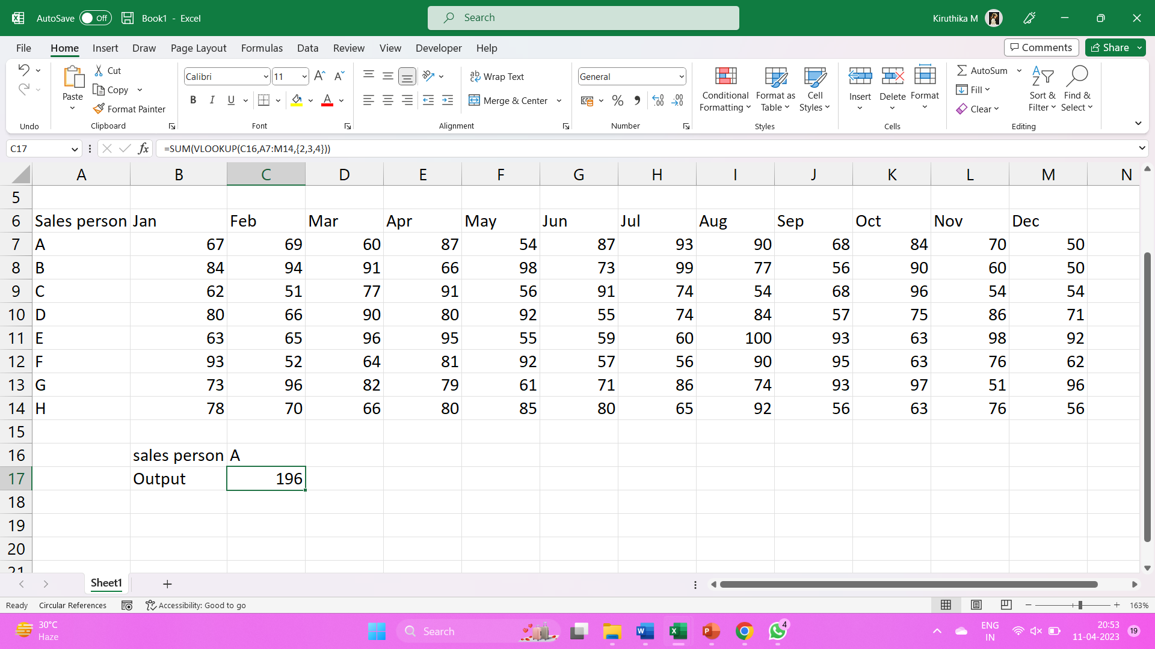

**EX.NO:3**

**DATE:**

**THERMOMETER CHART**

**Generate the below Thermometer Chart for the following data:**

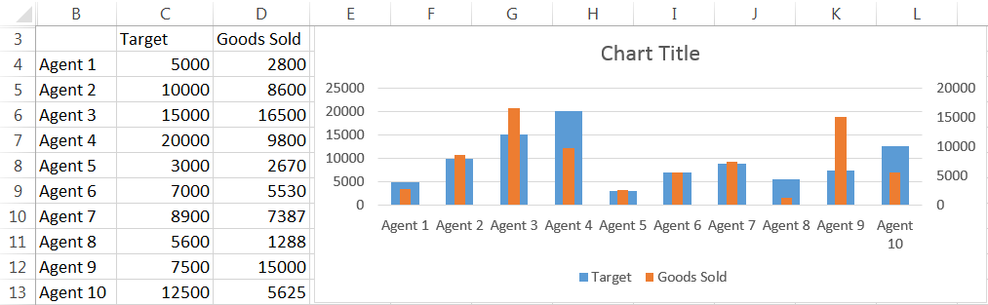

**Aim: T**o generate Thermometer chart for the given data using MS Excel.

**Algorithm:**

**Step 1:** Open MS Excel by using the command start – All Programs – Microsoft office – MS Excel.

**Start -> All Programs -> Microsoft Office -> MS-Excel**

**Step 2**: Type the given Agent name, Target and Goods sold fields and its values.

**Step 3**: Select the values of Agents, Target and Goods sold. Create a Column chart.

**Step 4**: To create a Column chart click

**Insert -> Column chart.**

**Step 5**: Now you can find two different bar charts for each agent. The Blue bar represents Target and the Orange bar represents Goods sold.

**Step 6**: Select the goods sold bar and right click the mouse. A popup menu appears. Select “Format Data Series” option from the menu.

**Step 7**: Enable **“Secondary axis”** radio button. Now you can find the orange bar overlaps the blue bar.

**Step 8**: Adjust its size by using “**gap width”** option to get the shape of Thermometer.

**Step 9**: Type the chart title as “Thermometer Chart”.

**Output:**

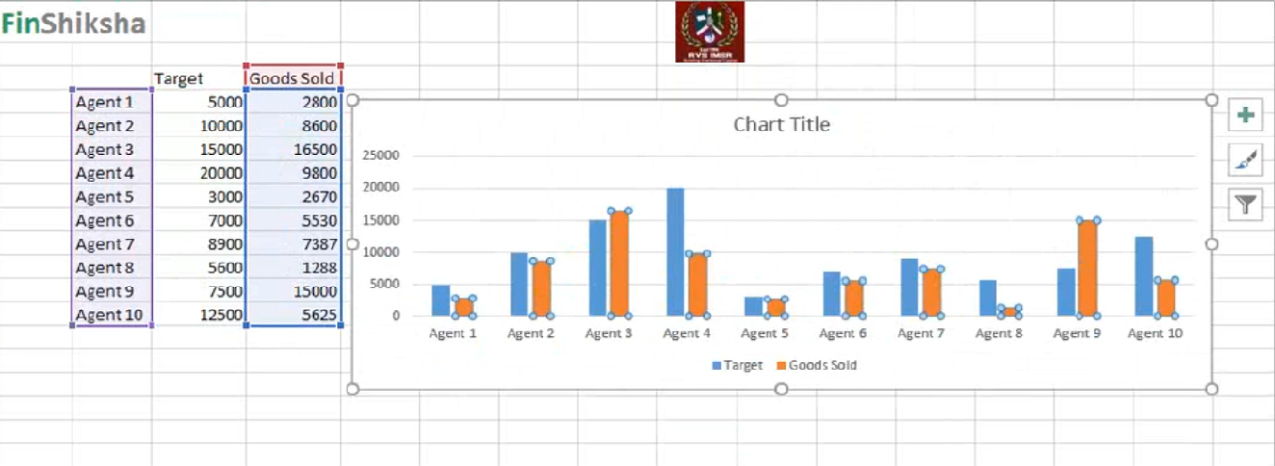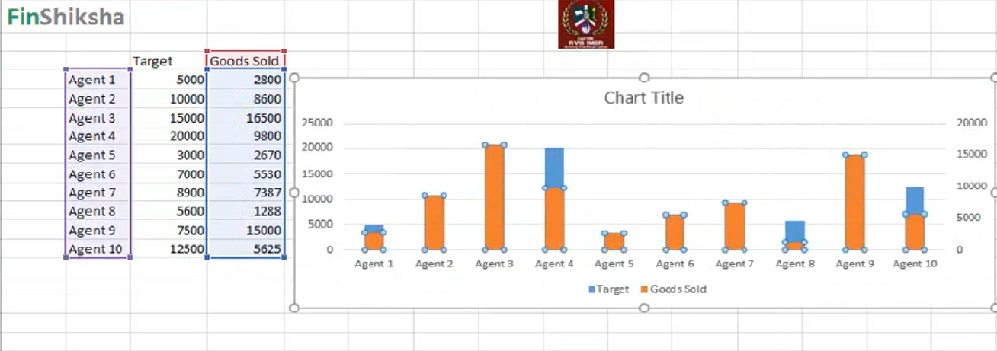

**EX.NO:4**

**DATE:**

**DYNAMIC LINKED LEGEND CHART**

**Create the below Dynamic Linked Legend Chart for the following data.**

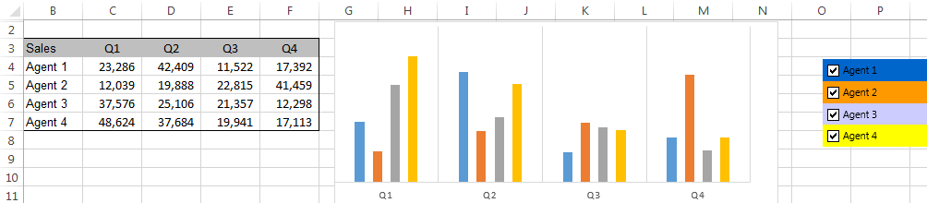

**Aim: T**o create Dynamic Linked legend chart for the given data using MS Excel.

**Algorithm:**

**Step 1:**  Open MS Excel by using the command start – All Programs – Microsoft office – MS Excel.

**Start -> All Programs -> Microsoft Office -> MS-Excel**

**Step 2:** Type the given Sales of agents for different quarters ie., Q1, Q2, Q3, Q4

**Step 3:** Select the values of sales, Q1, Q2, Q3 and Q4. Paste the values in another worksheet.

**Step 4:** Create checkbox for each Agents.

**Step 5:** To create a checkbox, use the command

**Developer –> Insert –> Form controls –> Checkbox.**

**Step 6:** Select the check box, drag it int the sheet. Name the check box as “Agent1”. Like this, create checkbox for Agent 2, Agent 3 and Agent 4.

**Step 7:** Assign a cell as cell link, Right click the mouse button and do as follows

**Format control –> Cell link –>Select a cell.**

**Step 8:** Set the cell A4 as a cell link for Agent 1 checkbox, A5 for Agent 2, A6 for Agent 3 and A7 for Agent 4.

**Step 9:** In the cell which is referred as cell link, it shows TRUE when the checkbox is enabled.

**Step 10:** To find the value of Agent 1 for Q1 type formula as below:

**=IF (A4=TRUE, Data! C4, NA())**

**Step 11:** By using the above formula, find the values of sales for all the Agents in different quarters.

**OUTPUT:**

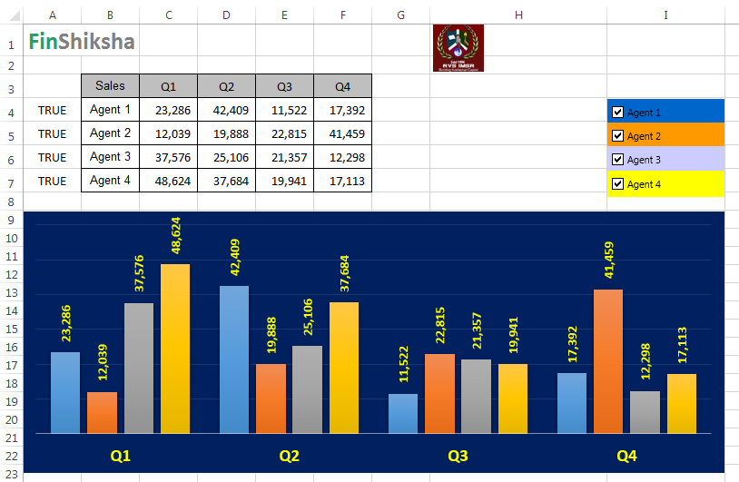

**EX.NO:5**

**DATE:**

**CREATING DASHBOARD**

**Create a Dashboard for the below data:**

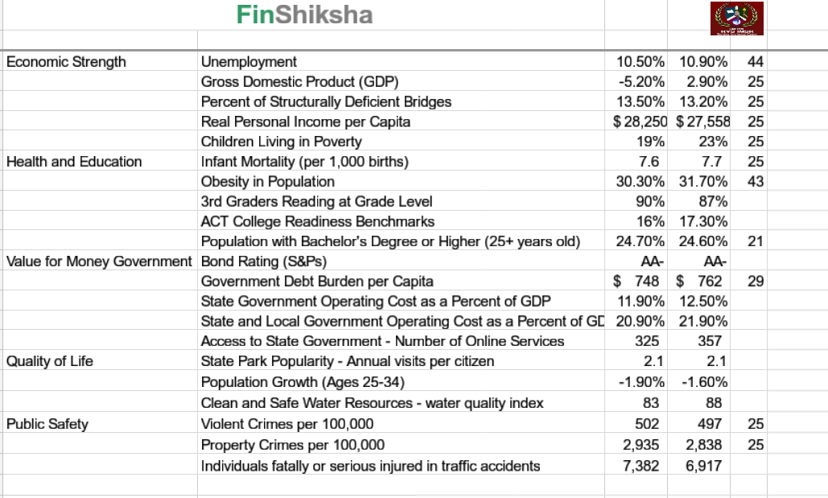

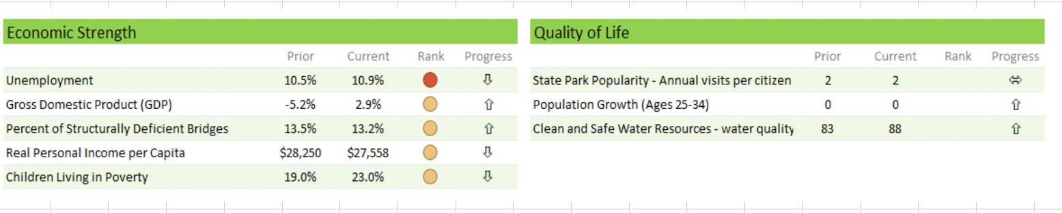

**Aim:** To create a Dashboard for the given data using MS – Excel.

**Step 1:** Open MS Excel by using the command start – All Programs – Microsoft office – MS Excel.

**Start -> All Programs -> Microsoft Office -> MS-Excel**.

**Step 2:** Create a separate sheet called Dashboard.

**Step 3:** Type the given area separately and type subtopics under each area.

**Step 4:** To copy the value of metric for Economic strength type formula asbelow

**=’Data Dashboard’! B5**

By using the above steps create separate table for each area and copy its metric value.

**Step 5:** To get the value of prior for each table, type formula as below:

**=VLOOKUP (metric value, ’Data Dashboard’! $B$5:$E$25, 2, 0)**

By using the given formula retrieve the value of prior for each metric.

**Step 6:** To get the value of current for each table, type formula as below:

**=VLOOKUP (Metric Value, ‘Data Dashboard’! $B$5: $E$25, 3, 0)**

**Step 7:** To get the value of Rank for each table, type formula as below:

**=VLOOKUP (Metric Value, ‘Data Dashboard’! $B$5:$E$25, 4, 0)**

**Step 8:** To find the value of progress type formula as below:

**= Current - Prior**.

By using the given formula retrieve the value of progress for each area.

**Step 9:** To set icons, select the Rank value do as follows,

**Home –> Conditional formatting –> Icon sets –> Shapes –> Circle.**

To set Icons, select the Progress and do as follows,

**Home –> Conditional formatting –> Icon sets –> Shapes –> Arrows.**

By using the above steps set Icons for Rank and Progress in each area.

**OUTPUT:**

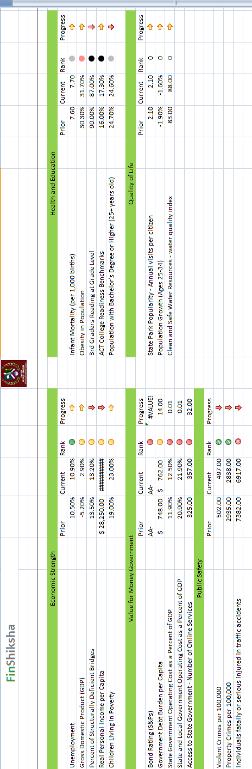

**EX.NO:6**

**DATE:**

**CREATING DASHBOARD USING SLICER**

**Write down the complete steps to create a Dashboard for the below data:**

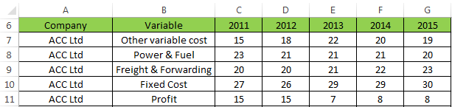

**Aim:** To Create a Dashboard for the given data using MS – Excel.

**Algorithm:**

**Step 1:** Open MS – Excel by using the command Start – All programs – Microsoft Office – MS-Excel.

**Start -> All Programs -> Microsoft Office -> MS-Excel**

**Step 2:** Type the given company field, Variable field, 2011, 2012, 2013, 2014, 2015 and its values.

**Step 3:** Create a Pivot Chart by selecting the value form **A6:A26** and click

**Insert –> Pivot Chart –> Pivot table –> Pivot chart.**

**Step 4:** Select new worksheet Radio button and click OK.

**Step 5:** Create Slicer for Company and variable by using the command select the below:

**Pivot table –> Analyze –> Insert slicer –> Enable company check box.**

**Step 6:** Create another pivot table for variable by using the command

**Insert – Pivot chart – Pivot table – Pivot chart.**

**Step 7:** Select Existing worksheet Radio Button select Location and click OK button.

**Step 8:** Create a slicer for variable by using the command select the variable

**Pivot table – Analyze – Insert slicer – Enable company check box.**

**Step 9:** Cut the slicers of Company and variable and paste it in a new sheet.

**Step 10:** Type 2011, 2012, 2013, 2014, 2015 as field names.

**Step 11:** Create a separate table for variable from O8 to O12 consists of Fixed Cost, Freight and Forwarding, Other variable cost, power and fuel, profit.

**Step 12:** To get the values for 2011 type formula as below:

**= OFFSET (INDEX (Data! $A$6:$A$25, MATCH (‘Workingsheet2’! $B$1, Data! $A$6:$A$25, 0),), MATCH (08, Data! $B$6:$B$25, 0)-1, 2)**

Use the same formula for all the columns, except the column number and variable reference. Change the column number to 3 when you drag and copy the formula to the next column and after O12, O8, O9, and O10. When you copy the formula to other rows.

**Step 13:** Now based on the selections in company and variable slicers, the value changes dynamically.

**Output:**

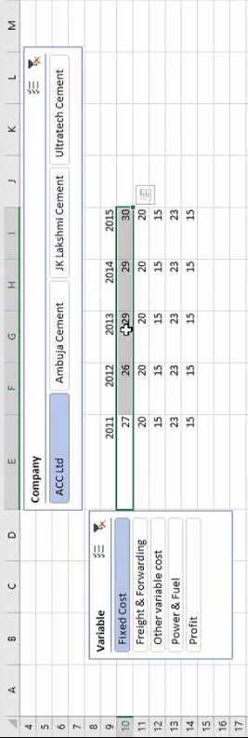

**EX.NO:7**

**DATE:**

**BASIC_MATH USING MACRO**

**Create a macro called basic_math to perform mathematical functions like product, sum, average and standard deviation of an Array for the below data:**

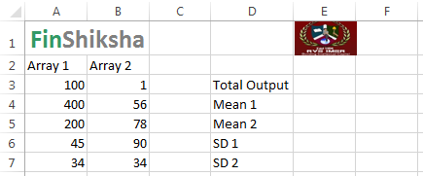

**Aim:** To create a macro called Basic_math to perform mathematical functions like Product, Sum, Average and Standard deviation of an array for the given data.

**Algorithm:**

**Step 1:** Open MS – Excel by using the command Start – All programs – Microsoft Office – MS-Excel.

**Start -> All Programs -> Microsoft Office -> MS-Excel**

**Step 2:** Type the given values of array1 and array2.

**Step 3:** To create a basic_math macro click the below:

**Developer tab –> Record Macro**

**Step 4:** Type the Macro name as Basic_math.

**Step 5:** Set a shortcut key like ctrl+L

**Step 6:** Set description and click OK button. Now your actions get recorded.

**Step 7:** Find the sum of two arrays by using the below function:

**= SUM (Array1, Array2)**

**Step 8:** To find Mean1, type formula as below:

**=AVERAGE (Array1)**

**Step 9:** To find Mean2, type formula as below:

**=AVERAGE (Array2)**

**Step 10:** To find the Total Output, type formula as below:

**=SUMPRODUCT (Array1, Array2)**

**Step 11:** To find SD1 type formula as below:

**=STDEV (Array1)**

**Step 12:** To find SD2 type formula as below:

**=STDEV (Array2)**

**Step 13:** To stop Macro recording, click Developer – Stop Macro.

**Step 14:** Now you can use the Basic_math macro to get the values whenever it’s needed.

**OUTPUT:**

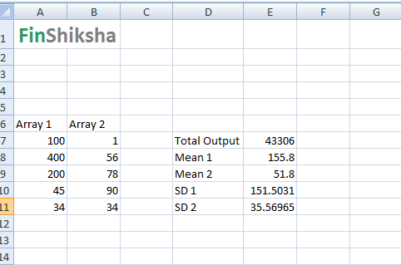

**EX.NO:8**

**DATE:**

**CALCULATE THE EMI USING MACRO**

Create a macro to calculate the EMI and repayment schedule for the below data:

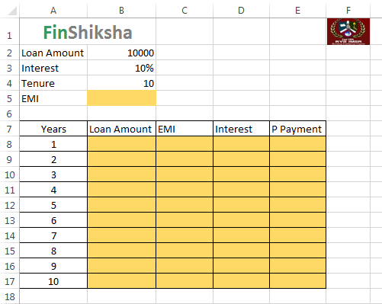

**Aim:** To Create a macro to calculate EMI and repayment schedule for the given data.

**Algorithm:**

**Step 1:** Open MS – Excel by using the command Start – All programs – Microsoft Office – MS-Excel.

**Start -> All Programs -> Microsoft Office -> MS-Excel**

**Step 2:** Type the given Loan amount, Interest, Tenure and its values.

**Step 3:** Type field names as years, Loan amount, EMI, Interest, p payment

**Step 4:** Create a Macro in the name of Amortization_Schedule.

**Step 5:** To create a Macro, click the below menu.

**Developer –> Record Macro.**

**Step 6:** Set Macro name as “Amortization_Schedule”, set a shortcut key and description, then click OK.

**Step 7:** To find EMI using the below formula:

**=PMT (Interest Rate, Tenure, -loan amount, 0)**

**Step 8:** Type 1 to 20 in year’s column.

**Step 9:** To find loan amount, type formula as below:

**=loan amount**

**Step 10:** To find EMI, type formula as below:

=PMT.

**Step 11:**  To calculate Interest type formula as below:

**=Interest rate * loan amount**

**Step 12:**  To calculate P.Payment, type formula as below:

**=EMI – Interest amount**

**Step 13:** To calculate loan amount for 2nd year, type formula as below:

**=1st year loan amount – P.Payment**

**Step 14:** To stop Macro recording, click

**Developer –> stop Macro.**

**OUTPUT:**

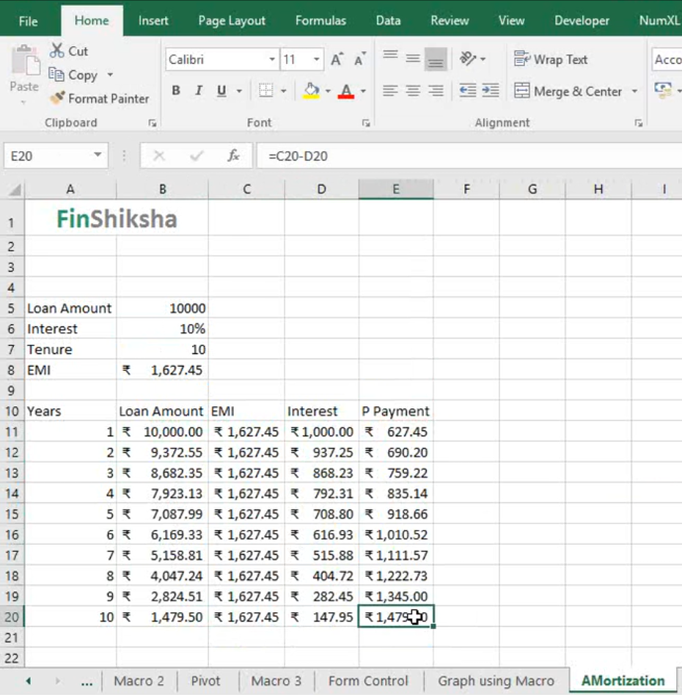

**EX.NO:9**

**DATE:**

**CALCULATING THE MEAN AND STANDARD DEVIATION**

**Calculate the Mean, Standard Deviation etc. mentioned in the below excel with the sample data:**

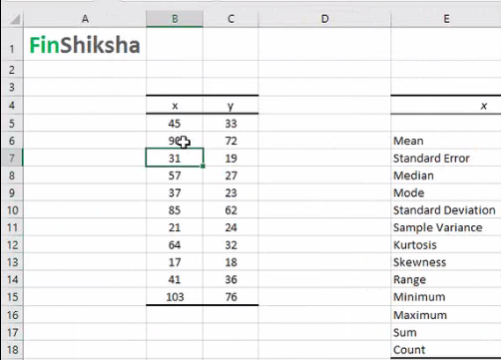

**CALCULATING THE MEAN AND STANDARD DEVIATION**

**Aim:**

To calculate statistical measures for the given data using MS – Excel.

**Algorithm:**

**Step 1:** Open MS – Excel by using the command Start – All programs – Microsoft Office – MS-Excel.

**Start -> All Programs -> Microsoft Office -> MS-Excel**.

**Step 2:** Type the given values of X and Y.

**Step 3:** To calculate Descriptive statistics for the given data, click the below:

**Data –> Data Analysis –> Descriptive Statistics**

**Step 4:** Select the values of X as Input range.

**Step 5:** Select output range and enable Summary statistics check box.

**Step 6:** Click OK Button. Now the output will be displayed in the selected Output range.

**OUTPUT:**

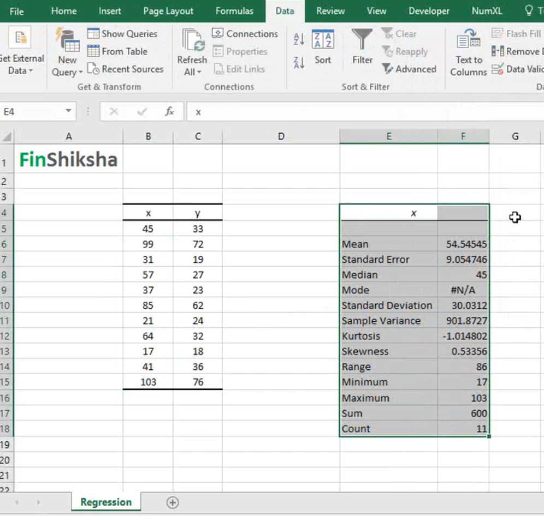

**EX.NO:10**

**DATE:**

**MULTIPLE REGRESSION**

**Calculate the Multiple Regression for the following data:**

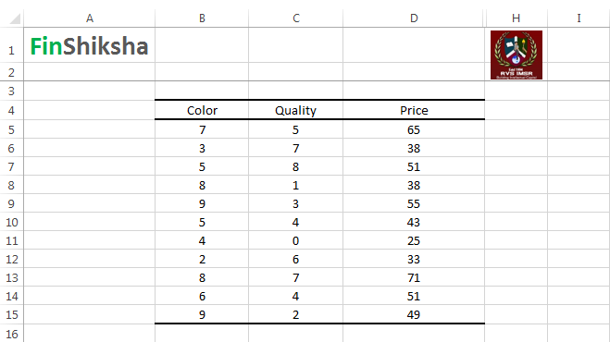

**Aim:**  To Calculate Multiple Regression for the given data using MS – Excel.

**Algorithm:**

**Step 1:** Open MS – Excel by using the command Start – All programs – Microsoft Office – MS-Excel.

**Start -> All Programs -> Microsoft Office -> MS-Excel**.

**Step 2:** Type the given Color, Quantity, Price fields and its values.

**Step 3:** To calculate multiple regression for the given data, click the below:

**Data -> Data Analysis -> Regression**

**Step 4:** We will get the dialogue box for providing the Input values as below:

**Input Y range : Select the Price Column Values**

**Input X range : Select the color and quantity column range values.**

**Step 5:** Check the Label check box if we are selecting the Color, Quality and Price column headings.

**Step 6:** Select Output range in the Same Sheet means, mention the Cell address.

**Step 7**: Select the Output range as New Worksheet, we will get the output in the new sheet.

**Step 8**: Click on the Residual check box if we want to calculate the residual values.

**Step 9:** Click OK button, we will get the Statistical Summary, ANOVA and Residual Output.

**Step 10:** From this data we can get the Intercept and Coefficient of Color and Quantity variables.

**OUTPUT:**

